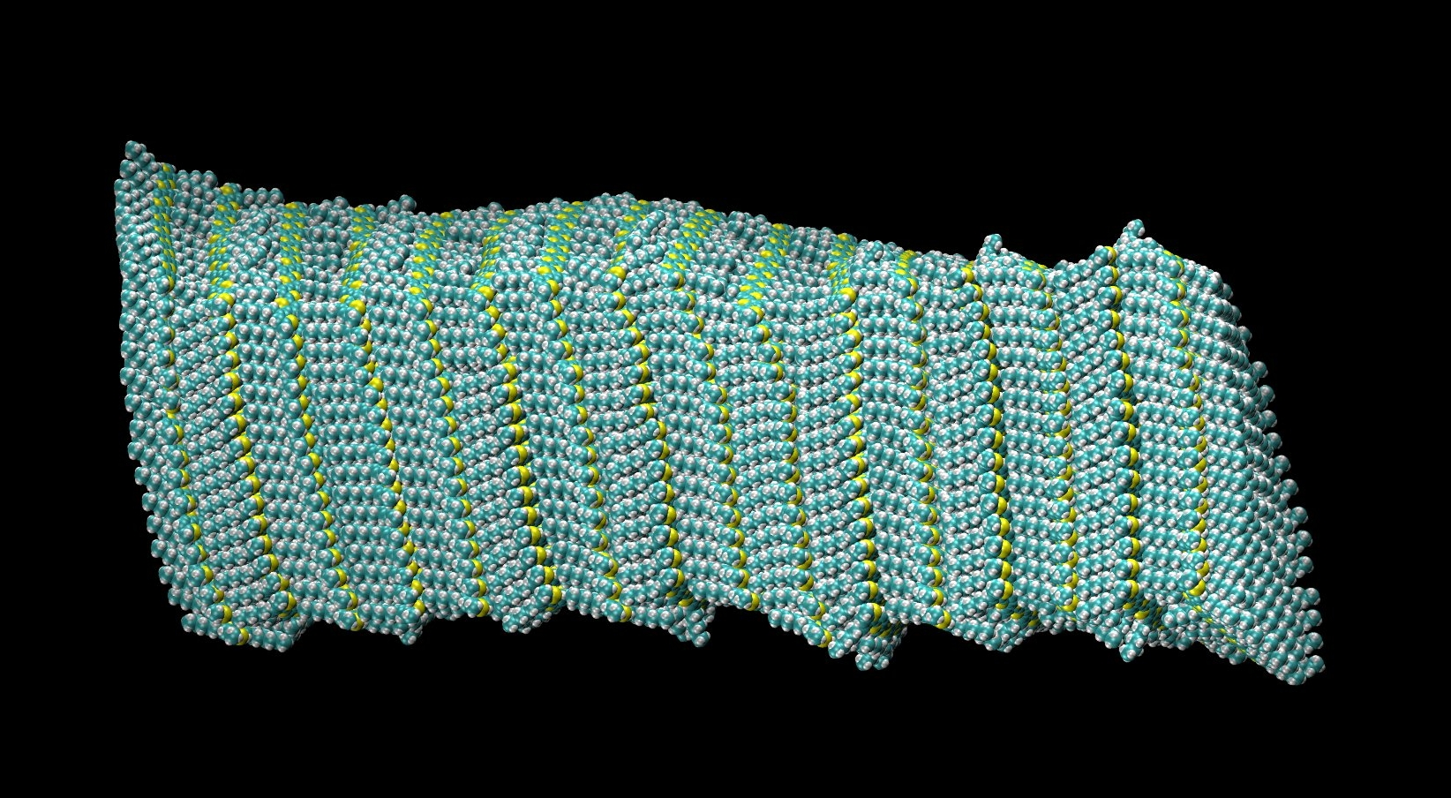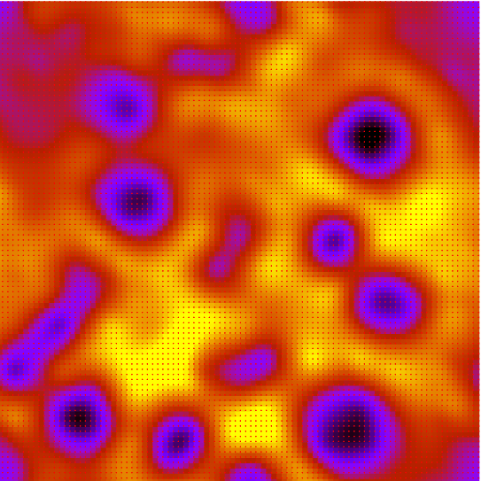

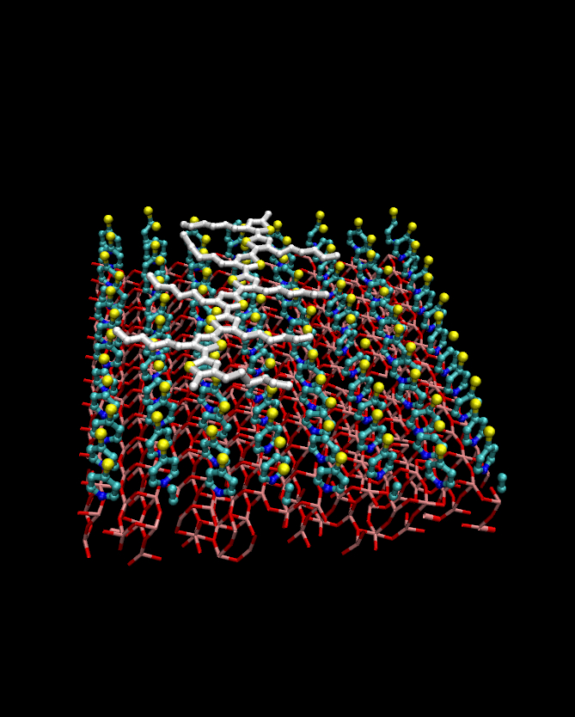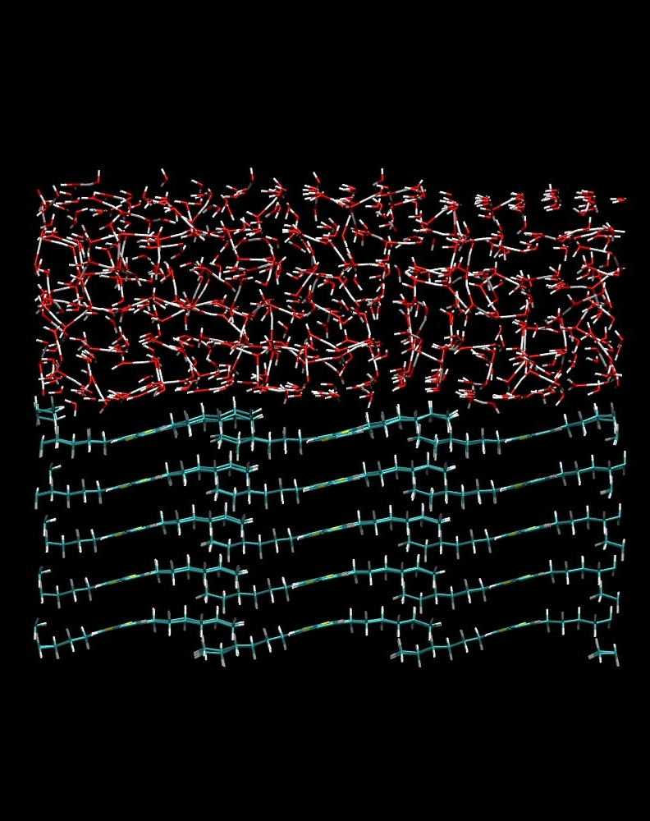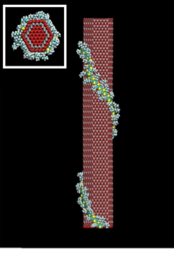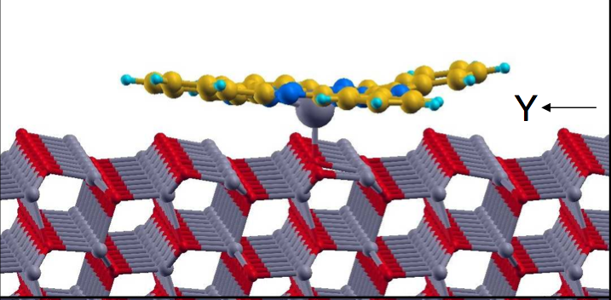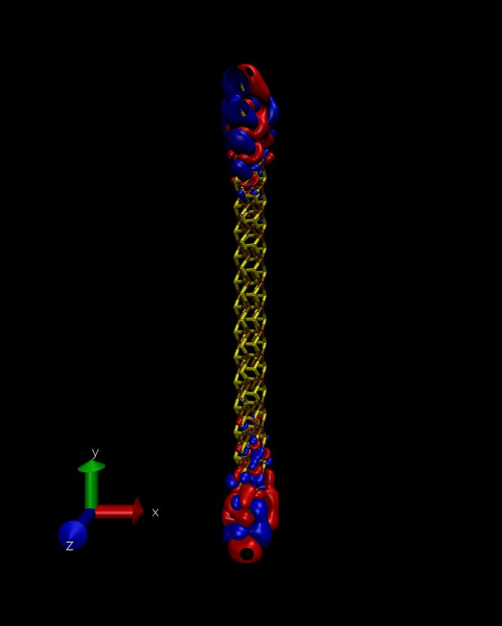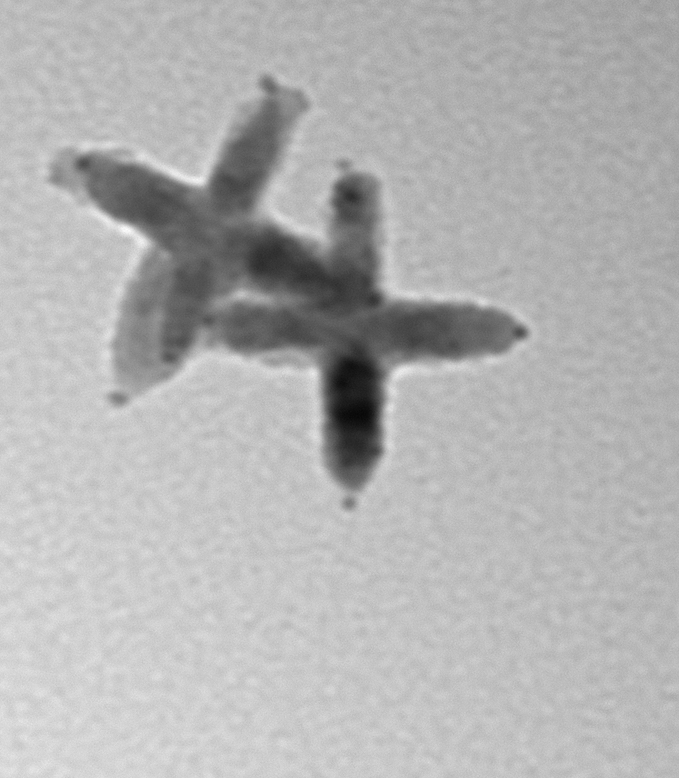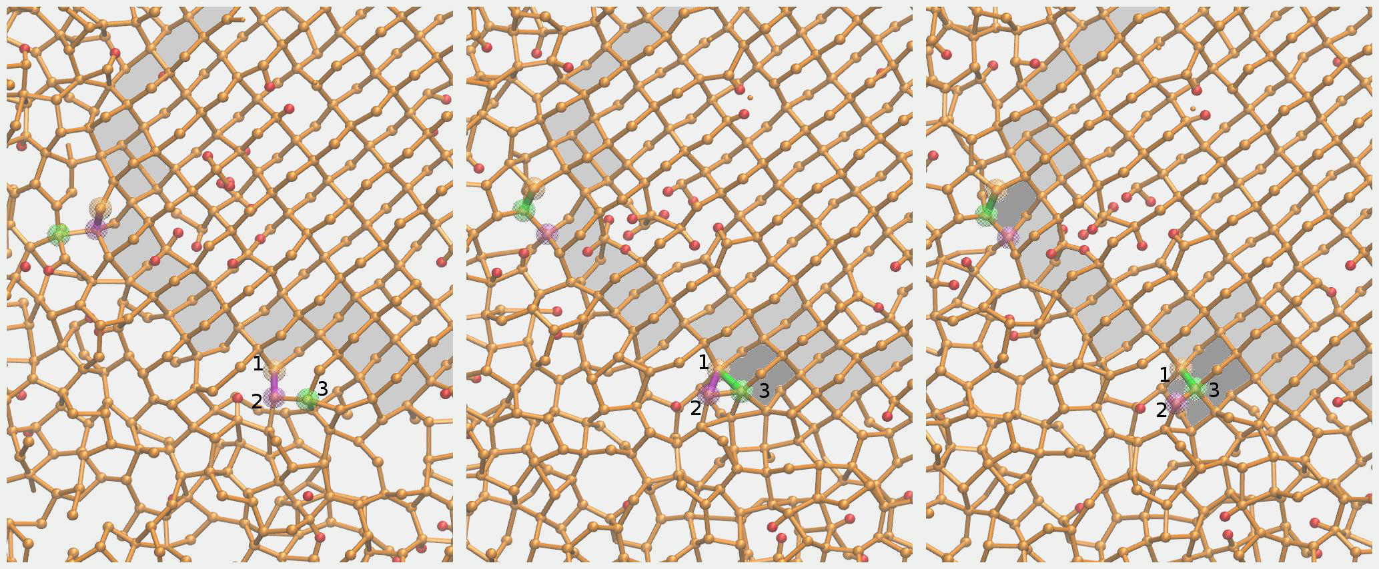

mattoni@iom.cnr.it

A. Mattoni Research Webpage

Optoelectronic properties of nanocrystalline silicon [A. Mattoni et al. PRB **79** 245302 (2009), L. Bagolini et al. PRL **104** 176803]

Polymer diffusion on a pyridine functionalized TiO2 (E. Canesi et al. Energy & Environmental Science. **5** 9068 2013)

The aim of the research activity is of improving the properties of functional interfaces for energy and in particular for **PHOTOVOLTAICS**. Future development will be in the direction of PHOTOCATALYSIS and thermovoltaics. The research is rooted on the predictive multiscale modeling based on atomistic methods (including classical molecular dynamics, semi- electronic methods and first-principles) are applied depending on the problem of interest.

# Semi-empirical electronic calculations

Semi-empirical tight binding can be applied to the calculation of optoelectronic properties of larges scale nanocrystalline systems ( Divide&Conquer)

Model potential molecular dynamics is intensively applied making possible to investigate molecular thermodynamic processes (e.g. self-assembling) and the microstructure evolution of complex phase systems (e.g phase transitions in mixed-phase amorphous crystalline systems)

# Multi-scale modeling of functional nanomaterials for Energy

# Model potential molecular dynamics

Hybrid liquid-polymer interfaces are investigated in order to understand the mechanism of photoexcitation-to-action potential transformation

# Hybrid liquid-solid interfaces

Low-dimensionality gives rise to exotic phenomena in hybrid nanostructures. Polymer wrapping occurs when polymers interact with elongated low dimension electron acceptor such as ZnO nanorods or carbon nanotubes

# Low dimension polymer based nanostructures

The properties of conductive polymers are strongly affected by their morphology, molecular aggregation and crystallinity both in the pure polymer phase that at the interface with electron acceptor substrates.

# Polymer microstructure

Hybrid donor-acceptor materials are formed by conjugated polymers interacting with metaloxide combining in principle technological advantages of both organic and inorganic components. Hybrid interfaces have not yet exploited their full potential in photovoltaics and deserves fundamental understanding of their structure and optoelectronic properties

# Polymer metal-oxide interfaces

The main research activity concerns the study of advanced functional nanomaterials for photovoltaics and in particular hybrid systems formed by polymers and inorganic electron acceptors

# Polymer based organic and hybrids nanomaterials

# Colloidal nanocrystals

The structure and optoelectronic properties of colloidal metal chalcogenides and metaloxides are investigated for applications in photovoltaics photocatalysis. Several ongoing investigations concerns optoelectronic properties of Bi2S3,Sb2S3,ZnS,ZnO,TiO2,CdS nanostructures.

# Nanocrystalline silicon-based systems

The solid-phase recrystallization of nanocrystalline silicon provides the possibility to realize embedded nanocrystals with great potential in photovoltaics. The microstructure evolution under thrmodynamical conditions and the corresponding effect on confinement phenomena and optoelectronic properties are investigated by combining first-principles and semi-empirica methods.

# Colloidal eco-friendly nanocrystals for Photovoltaics and photocatalysis