Post-Doc in Computational Physics

Physics-based and Machine Learning Force-Fields for Hybrid Perovskites

Tel.: +39 070 6754875 Fax: +39 070 6754892
EMAIL: mattoni@iom.cnr.it

 |  | Post-doc position on “Physics-based and Machine Learning Force-Fields for Hybrid Perovskites” available at CNR-IOM Cagliari in Mattoni group (www.dsf.unica.it/~mattoni ) .
Contract and Salary |  | The two-year position will start in March/April 2024. Net salary is within 1600 to 2200 euros net per month depending on the candidate research experience.
Activity |  | 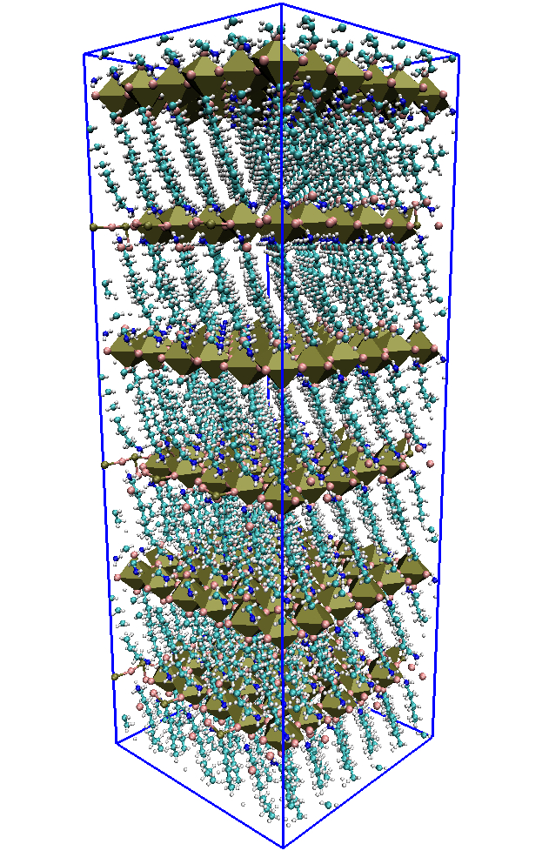  The successful candidate will play a significant role in developing and applying molecular dynamics methods to the study of crystal growth and stability of non-toxic 2D/3D hybrid perovskites.  The candidate will develop physics-based force-fields (of the MYP family developed by Mattoni et al.) as well as machine-learning models (based on atomic cluster expansion) for novel perovskites. Ab initio calculations will be necessary to generate atomistic datasets and trajectories.  The computational activity will be developed within ongoing collaborative projects involving several international experimental and theoretical groups (University of Cagliari, Kyoto University, Cambridge University, University of Groningen).
Criteria |  | Eligible candidates should have a Ph.D. degree in physics or chemistry or materials science and a strong motivation in theory and computational methods for condensed matter physics.  The candidate should demonstrate experience with atomistic methods such as DFT calculations (e.g. by Quantum Espresso, VASP, etc) and/or classical molecular dynamics (e.g. LAMMPS, DL_POLY).  Previous knowledge of UNIX/Linux environment and programming (either Fortran2008 and/or C/C++ and/or Python) is necessary. Experience in machine learning methods is preferred but not mandatory.  Very good communication skills in English and marked enthusiasm for research.
Host Institution and Locaiton |  | CNR-IOM Cagliari is part of the Istituto Officina dei Materiali (www.iom.cnr.it) and it is located at the Physics Department of the University of Cagliari.  Cagliari is the main metropolitan area of the Sardinia island (renowned for beautiful beaches) with an above-average quality of life (https://expiter.com/province/cagliari/) and good airplane connections.
Application |  | Informal enquiring and a CV should be sent as soon as possible to: Alessandro Mattoni (CNR-IOM Cagliari, mattoni@iom.cnr.it)

